**Custom Power Devices**

**These devices are used to mitigate the power quality problem in the distribution system.**

**Custom Power Devices are the D-FACTS that are used in the distribution systems.**

**Main three types of D-FACTS (D-STATCOM, DVR, UPQC**

**DSTATCOM (Distributed Static Compensator): It is used to mitigate the Current based Active power P and Reactive power Q Problems (reactive power, harmonics, unbalanced load /power, poor voltage regulation)**

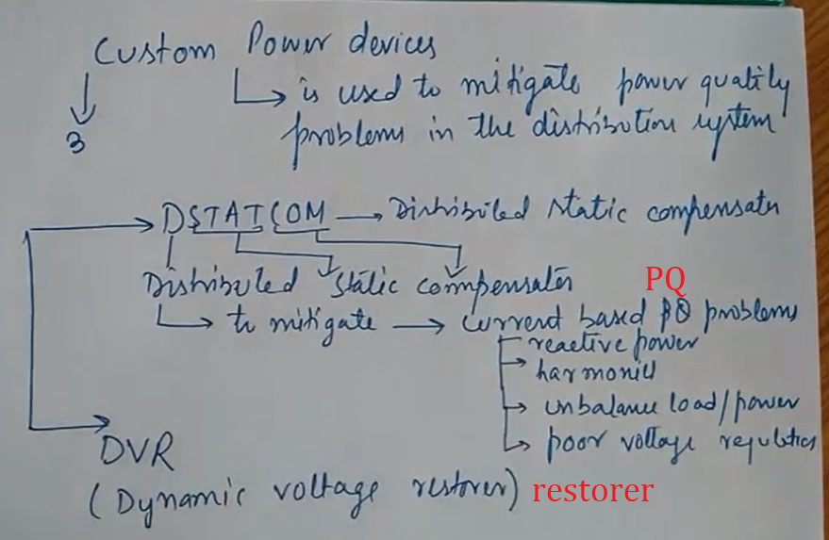

DVR (Dynamic Voltage restorer): It is used to mitigate the voltage based real and reactive problems (Voltage sag, Voltage swell, voltage harmonics, unbalance voltage etc

)

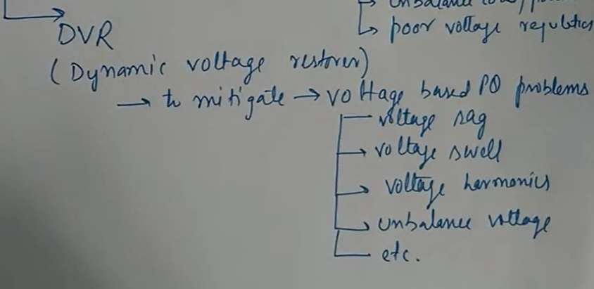

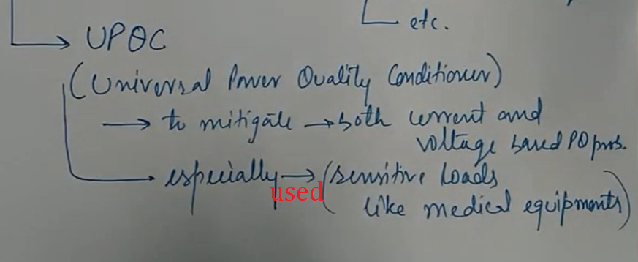

**m Power Devices**? Definition of **Custom Power Devices**: Are the D-FACTS that are used in distribution systems like DVR, D-STATCOM, UPQC, and ...